Homework Assignment from Chapter 6 (50 pts)

1. 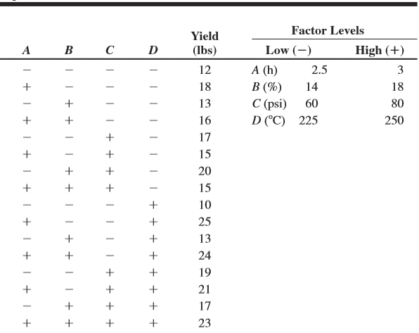In a process development study on yield, four factors were studied, each at two levels: time (A), concentration (B), pressure (C), and temperature (D). A single replicate of a $2^{4}$ design was run, and the resulting data are shown in Table
2. (8 pts) Construct a normal probability plot of the effect estimates. Which factors appear to have large effects?
3. (8 pts) Conduct an analysis of variance using the normal probability plot in part (a) for guidance in forming an error term. What are your conclusions?
4. (8 pts) Analyze the residuals from this experiment. Does your analysis indicate any potential problems?
5. (6 pts) Can this design be collapsed into a $2^{3}$ design with two replicates? Why?
6. (6 pts) What is your conclusion for maximizing the yield?
7. Semiconductor manufacturing processes have long and complex assembly ﬂows, so matrix marks and automated 2d-matrix readers are used at several process steps throughout factories. Unreadable matrix marks negatively affect factory run rates because manual entry of part data is required before manufacturing can resume. A 24 factorial experiment was conducted to develop a 2d-matrix laser mark on a metal cover that protects a substrate-mounted die. The design factors are A = laser power (9 and 13 W), B = laser pulse frequency (4000 and 12,000 Hz), C = matrix cell size (0.07 and 0.12 in.), and D = writing speed (10 and 20 in./sec), and the response variable is the unused error correction (UEC). This is a measure of the unused portion of the redundant information embedded in the 2d-matrix. A UEC of 0 represents the lowest reading that still results in a decodable matrix, while a value of 1 is the highest reading. A DMX Veriﬁer was used to measure UEC. The data from this experiment are shown in Table

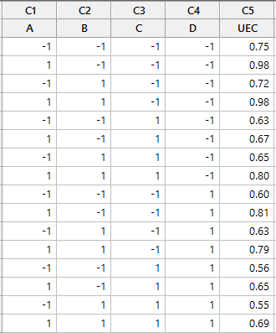

1. (7 pts) Analyze the data from this experiment. Which factors signiﬁcantly affect UEC?
2. (7 pts) Analyze the residuals from this experiment. Are there any indications of model inadequacy.